
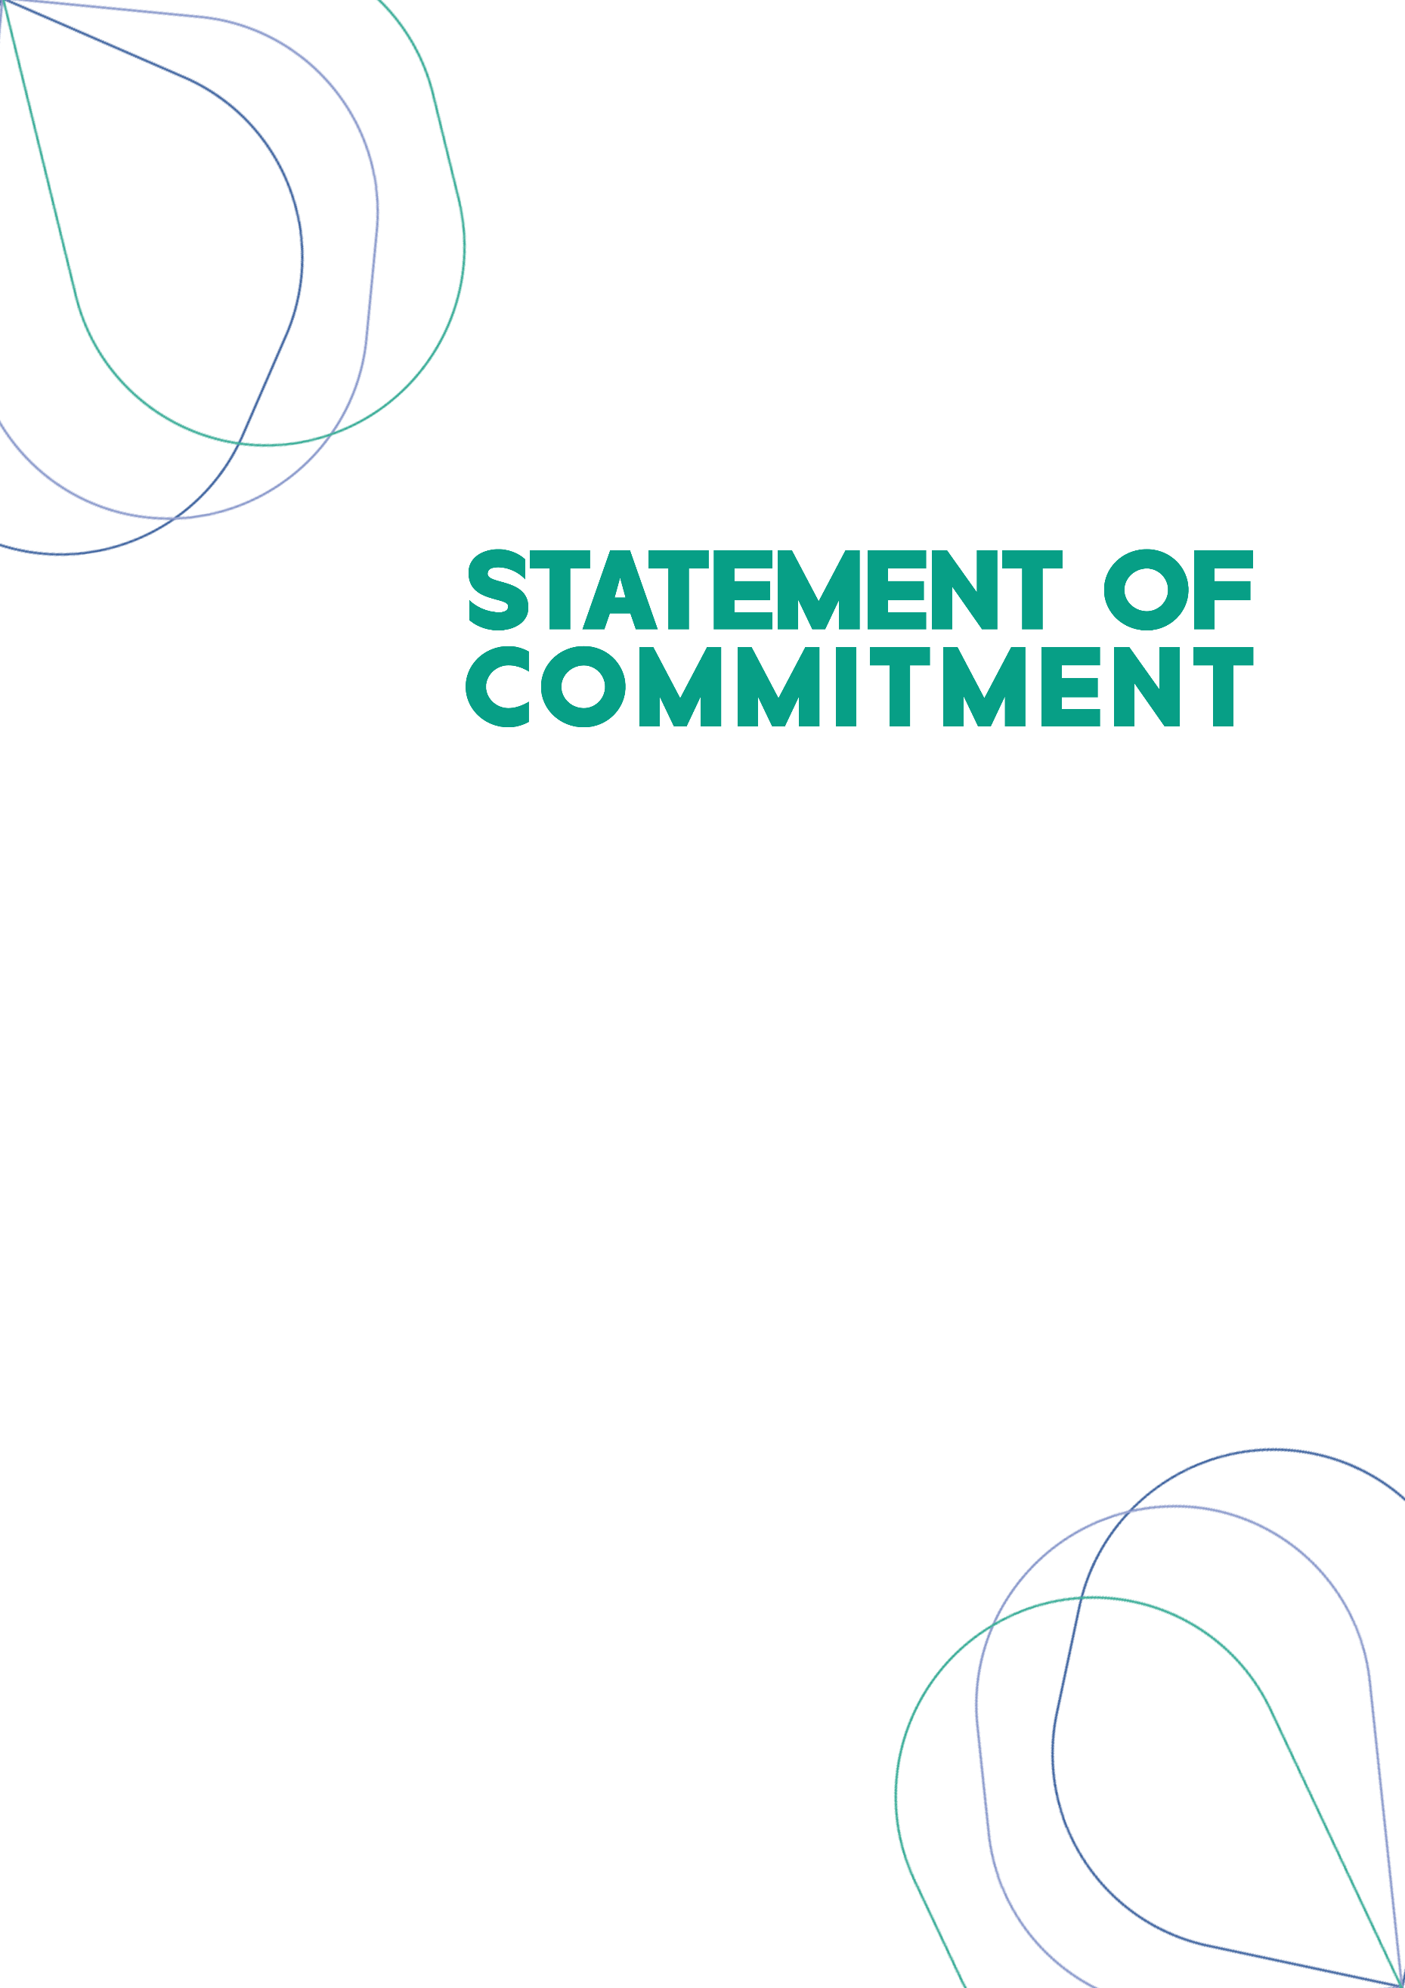
Narangba Baptist Church is committed to being a safe space for all and will provide a supportive environment by:
- Ensuring staff and volunteers are appropriately screened and trained and behave in a manner that resembles and represents Christ's attitude and approach.
- Providing safe environments and ministries that promote spiritual, social, and physical safety and personal growth and development.
- Promoting a culture of safety throughout the Church, constantly communicating, and reinforcing our commitment across all aspects of ministries and activities.
We have zero tolerance for any form of abuse or harm to children, young people and vulnerable adults and are committed to actively seeking to prevent this abuse and harm. This includes maintaining an open and aware culture, treating all concerns and allegations raised seriously, not minimising the impact of abuse and harm on the victim, and promptly responding to all concerns and allegations.
Narangba Baptist Church is dedicated to providing safe spaces for everyone and are committed to fulfilling our responsibilities under the eight Mandatory Requirements of a child and youth risk management strategy as set out by the Queensland Government Blue Card Services.

